Experiment 2
Software Requirements Specification
for
Recruitment System
Prepared by Aiman Raza, Agrim Kansal and Aizanul haque
Delhi Technological University, New Delhi
25th March, 2025
Table of Contents
Table of Contents ii

Revision History iii
1. Introduction 1
1.1 Purpose 1
1.2 Document Conventions 1
1.3 Intended Audience and Reading Suggestions 1
1.4 Project Scope 1
1.5 References 1
2. Overall Description 2
2.1 Product Perspective 2
2.2 Product Features 3
2.3 User Classes and Characteristics 4
2.4 Operating Environment 6
2.5 Design and Implementation Constraints 7
2.6 User Documentation 7
2.7 Assumptions and Dependencies 7
3. External Interface Requirements 8
3.1 User Interfaces 8
3.2 Hardware Interfaces 8
3.3 Software Interfaces 9
3.4 Communications Interfaces 9
4. System Fetaures 9
4.1 System features and Priority matrix 9
4.2 Functional Requirments 9
5. Other Nonfunctional Requirements 10
5.1 Performance Requirements 10
5.2 Safety Requirements 10
5.3 Security Requirements 10
5.4 Software Quality Attributes 11
5.5 Business Rules 11

Revision History
Name | Date | Reason For Changes | Version
Recruitment System Version 1.0 | 25/03/2025 | Initial Version | 1.0

Introduction

Purpose
The purpose of this Recruitment System is to make the hiring process easier and more efficient. It provides a digital platform where companies can post job openings, job seekers can apply, and recruiters can manage applications and interviews. The system reduces manual work, ensures smooth communication between employers and applicants, and helps in finding the right candidates quickly. This project is especially useful for organizations, recruitment agencies, and universities handling large numbers of job applications.

Document Conventions
This document follows standard software documentation practices to ensure clarity and organization. Headings are structured hierarchically, key terms are defined, and bullet points improve readability. Functional and non-functional requirements are categorized to help developers, testers, and stakeholders easily understand the system.

Intended Audience and Reading Suggestions
This document is intended for developers, recruiters, HR personnel, job seekers, project managers. Developers will build and maintain the system, while recruiters and HR teams will use it for hiring. Job seekers can apply for jobs, and project managers will oversee development. College faculty will review it for academic evaluation. It is recommended to read the Introduction and System Overview before delving into technical details.

Project Scope
This project aims to develop an efficient recruitment system with key features such as job posting management, application tracking, interview scheduling, automated notifications, and messaging between recruiters and applicants. Designed for HR departments, organizations, and recruitment agencies, it streamlines hiring. Future enhancements may include AI-based resume screening, video interviews, and LinkedIn integration.

References
The Document refers to the following assignment submitted:
Experiment 1
Experiment 2
Experiment 3

Overall Description

Product Perspective

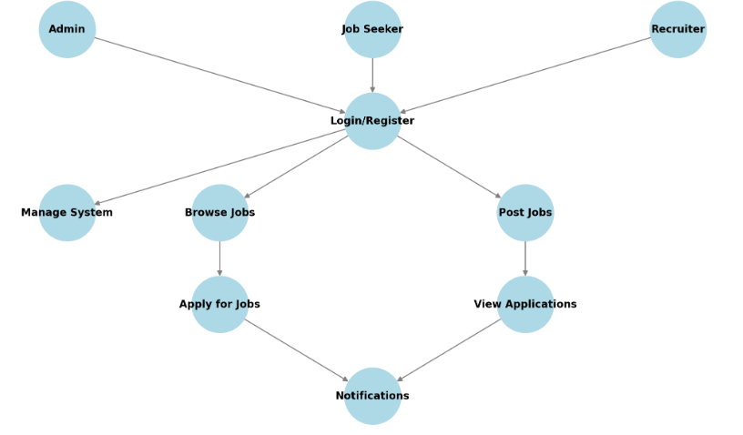

In the “Recruitment System”, We will be having a user interface for the admin, applicant and company. The user can log in to their account. Depending on the user, the utilities will be decided. The applicant can login to their respective account and can apply for the respective post available. If the applicant doesn’t have an account, then he/she can create an account and can apply or the jobs. The company can login to their account and can update the details of the jobs available. If the company don’t have an account the they can create and account and can update the job details. Admin will already be having an ID and password. The admin will login and manage the applicant and company’s activities. After the creation or the login of the user, a successful message will be displayed to the user.

Product Functions
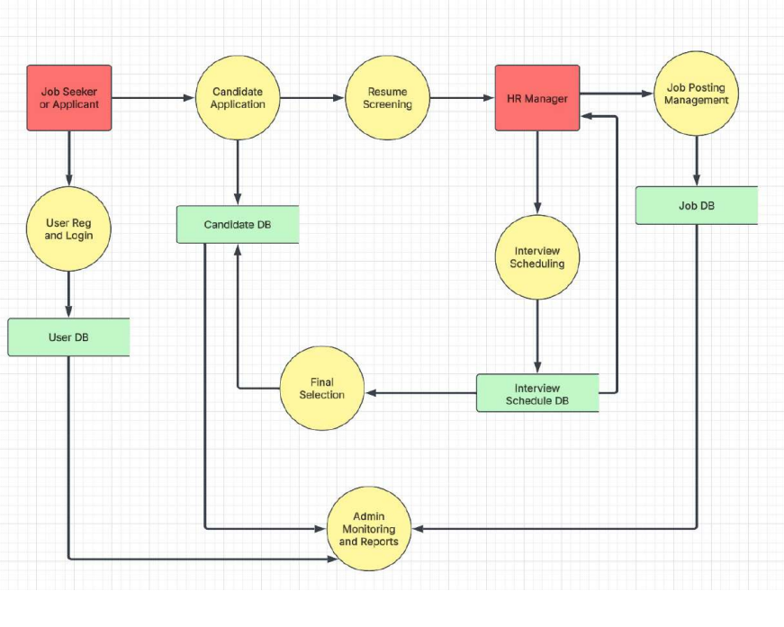
The above level 1 DFD clearly shows various processes associated with the project and how the data flows between the entities and databases. The applicant can create an account. If the account already exists, they can search for available jobs, view job details, and apply. They can also update personal details and change their password. The company handles resume screening and interview scheduling. They manage job postings and store job details in the job database. The company can create an account or log in to post job openings and track applicant submissions. The admin oversees all activities, including applicant and company validation, managing discrepancies, and monitoring reports. Admins can also remove companies or applicants if necessary. The final selection process ensures that only qualified candidates proceed to hiring.

User Classes and Characteristics
The actors and use cases are clearly shown in below use-case diagram:

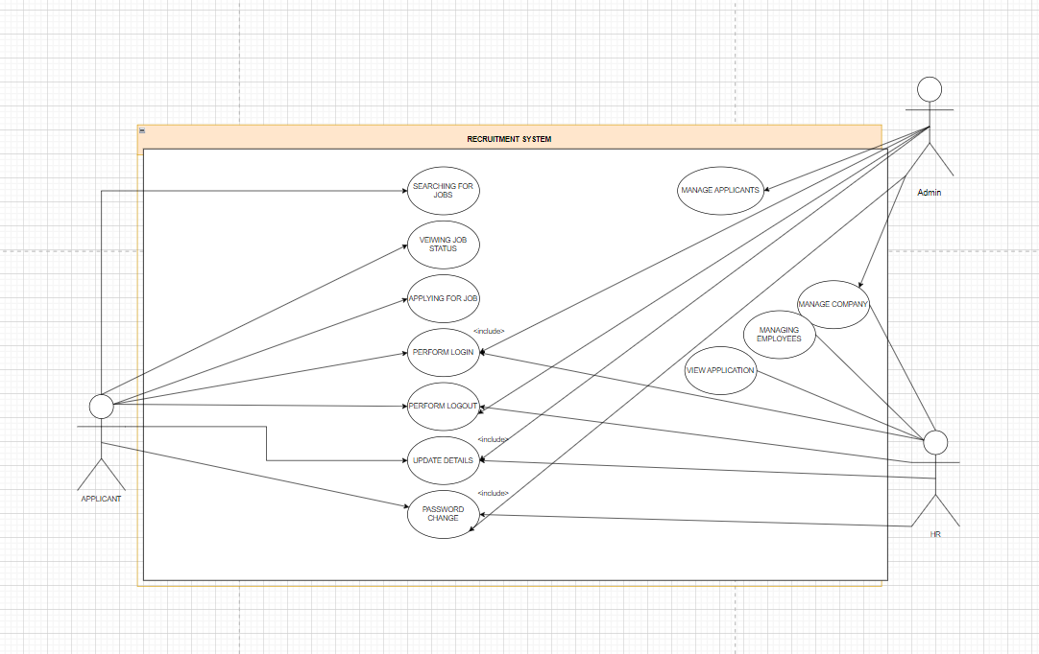

In software and systems engineering, a use case is a list of actions or event steps typically defining the interactions between a role (known in the Unified Modeling Language as an actor) and a system to achieve a goal. The actor can be a human or other external system. In systems engineering use cases are used at a higher level than within software engineering often representing missions or stakeholder goals. The following are the actors who perform the use cases as stated above:

S.No | Actor Name | Description/Actor’s Role
01 | Admin | Manage Applicants & companies.
02 | Applicant | Apply for jobs, view job status & search jobs.
03 | Company | Post jobs & view applications of applicants.

S.No | Use Case Name | Description | Pre-condition | Post-condition
01 | Perform Login | User (admin, applicant, or company) can perform login. | User having account | Login successful
02 | Perform Logout | User (admin, applicant, or company) can perform logout. | User logged in | Successfully logged out
03 | Update Details | User (admin, applicant, or company) can update their details. | User logged in | View details
04 | Change Password | User (admin, applicant, or company) can change passwords. | User having password | Password is reset.
05 | Manage Company | Admin can manage companies. | Existing admin & at least one company | Validated by admin & company can continue with its account
06 | Manage Applicants | Admin can manage applicants. | Existing admin & at least one applicant | Validated by admin & applicant can continue with its account
07 | Apply for Jobs | Applicant can apply for a job. | Job should be posted by company & applicant must be eligible for job | Applied for job successfully & wait for response from company
08 | View Job Status | Applicant can view job status. | Applicant must have successfully applied for job. | Viewed job status & can accept job if selected, else can apply for another job.
09 | Search Jobs | Applicant can search for a job. | Applicant must have an account & be logged in. | Can find a job or not.
10 | Post Jobs | Company can post jobs. | Company must have an account & be logged in. | Applicant can now apply for jobs.
11 | View Applications | Company can view applications of applicants. | At least one applicant must have applied. | Company can react to applications.
12 | Get Help | User can get help for login. | User should have tried for it or just get help if does not know how to login. | User will now login using this help.

Operating Environment
The recruitment system will be designed to work across web and mobile platforms. It will use a JavaScript-based full-stack approach with RESTful APIs, ensuring a smooth and responsive experience for all users — job seekers and recruiters alike. The system will store data in a MySQL database and can be deployed on any web server or cloud service. It is modular and scalable, allowing for future enhancements like chatbot integration, email alerts, or resume parsing.
The system will be built with the help of the following softwares:

Sr. No. | System | Development Environment | Description
1 | Recruitment System | Backend (Node.js + Express.js) | - Node.js is a runtime environment for executing JavaScript code server-side.  - Express.js is a lightweight web application framework built on Node.js.  - Together, they allow fast, scalable backend development with RESTful APIs.  - The backend will handle user authentication, job posting, application tracking, and more.  - REST APIs ensure smooth communication between frontend and backend.
2 | Recruitment System | Frontend (React.js) | - React.js is a JavaScript library for building interactive UIs using components.  - It allows reuse of UI elements and efficient state management.  - Suitable for building dynamic, responsive web interfaces for job seekers and recruiters.  - Ensures consistency and speed across devices.
3 | Recruitment System | Database (MySQL) | - MySQL is a relational database used to store structured data.  - Stores user profiles, job listings, applications, interviews, and feedback.  - Supports efficient querying and integration with backend APIs.  - Ideal for systems needing reliability and scalability.

Design and Implementation Constraints
The following Design and Implementation Constraints are applicable for the Recruitment System:

- The system is designed to be cross-platform compatible. It should support a wide range of hardware and operating systems, including mobile and web platforms. The application should be lightweight and portable.
- To prevent multiple applicants of the same category from logging into the same account, a secure authentication mechanism should be implemented.
- The system is expected to store a large volume of data, with an estimated capacity of 64GB or more to handle applicant profiles, job postings, and application history.
- Initially, the system should be available on Android and web platforms with support for Android versions 5.1 and above. Later, it should be expanded to iOS and desktop platforms.
- To assist applicants in selecting companies and preparing for interviews, a machine learning algorithm will be designed and trained. It will analyze historical recruitment data to predict required skill sets and improve applicant job recommendations.
- The database shall be maintained by the admin, and accounts that have been inactive for over one year shall be archived. The restoration of such data will be managed by the admin if needed.
- As the system will be used by both applicants and companies, usability aspects such as navigation, accessibility, and responsiveness should be prioritized.
- The system should provide an interactive UI that is engaging for companies, encouraging them to post jobs and interact with applicants effectively.

User Documentation
The following documents shall be prepared:
1. Installation Guide
2. User Manual for end users
3. Even video tutorials of installation of the recruitment will be provided as video format.

Assumptions and Dependencies

    - Key Assumptions
- The platform is designed for a specific group of users, such as students, job seekers, or professionals. While it may start with a smaller audience, it can later expand to more users.
- Each user account (whether an applicant or recruiter) will be unique and secure to prevent unauthorized access.
- Each company account will also be unique, ensuring that only verified company representatives can post jobs and communicate with applicants.
- Applicants can apply to a limited number of jobs per company to keep the process fair and prevent excessive applications.
- A smart recommendation system will help applicants find suitable jobs and prepare for interviews by suggesting necessary skills and checking if they qualify for a position.
- The system will handle large amounts of data, including job listings, applications, and user profiles. It will also update regularly to keep the job market information fresh and relevant.

External Interface Requirements

User Interfaces
(visuals to be pasted after the working on the prototype)

The user interface section defines the way various stakeholders interact with the system. All the screens will be developed to work on android mobile. Error messages will appear as a popup on the screen. The maximum size of error message will be 40 characters. Buttons will there to make the navigation simpler. A first-time user of the mobile should see the login screen when he/she will open the android application. If the user has not registered to the, then he/she should be able to redirect to the sign-up page from login screen. Every user should have the profile where he/she can apply for the job. After the creation of account, the user can login to the application and will be able to apply for the jobs.

Similarly, here will be the same option for the login of the company where the company can sign up and login. An Admin should also be log in to the web portal where he/she can administer the system by managing the applicant and company using the application. After performing login, the user will be able to see the side menu. After performing login by the company, the company will be able to see side menu.

After performing login by the admin, the admin will be able to see side menu

User can select the particular section and can perform the respective task. There is an option to add the jobs for the company where the companies can add the vacancies for their companies they have.

Hardware Interfaces
Since the mobile application does not have designated hardware, it does not have any hardware interface. The hardware connection between the database server and application is managed by the underlying operating system on the mobile phone.

Software Interfaces
The system is self-contained and no data is supposed to share with the third party. The communication of the mobile application between the database consists of both reading and modifying the data, while the communication between the database and the mobile application consists of only reading operation.

Communications Interfaces
The communication between the different parts of the system is important since they depend on each other. However, in what way the communication is achieved is not important for the system and is therefore handled by the underlying operating system for the mobile application

System features

System Features and Priority Matrix
The table below outlines the system features along with their priority levels:
Sr. No. | Feature | Priority
1. | Create an Account | High
2. | Log In | High
3. | Apply for Jobs | Medium
4. | View Job Status | Low
5. | Search Jobs | Low
6. | Change Password | Low
7. | Manage Student | High
8. | Manage Company | High
9. | Post Jobs | High
10. | View Application | Medium
11. | Call for Interview | Medium

Functional Requirements
The table below describes the functional requirements of the system:
Feature | Remark
Update Information | This functionality will update the information of the applicants.
Change Password | This functionality is used to change the password of the account.
Sign Up | This functionality is used to sign up for applicants, admins, and companies.
Log In | This functionality is used to log in for admins, applicants, and companies.
Apply for Jobs | This functionality is used for applicants to apply for jobs.
Post Jobs / Add Job Details | This functionality is used by companies to post jobs.
View Job Status | This functionality is used to view job status by the applicants.
Search Jobs | This functionality is used to search for jobs.
Manage Applicant | This functionality is used by the admin to manage applicants.
Manage Company | This functionality is used by the admin to manage companies.
View Applicant Application | This functionality is used to view applicant applications.

Other Nonfunctional Requirements

Performance Requirements
1. The completely separate business logic at admin side from the applicant interface ensures good performance.
2. The system exhibits high performance because it is well optimized. The business logic is clearly separate from the UI.
3. System should be able to scale to many users concurrently.
4. The response time of processes is as follows:
- Applicant Registration max 10 seconds
- Company Registration max 15 seconds
- Company Job posting max 15 seconds
- Student applying for job max 20 seconds
5. System is available 24 by 7.

Safety Requirements
1. Errors will be minimized and an appropriate error message that guides the user from an error will be provided.
2. Validation of users input is highly essential.
3. The time taken to recover from the error is less than 10 second.

Security Requirements
1. The system is provided a high level of security and integrity of the data held by the system.
2. only authorized personnel such as admin can gain access to the to the private data and only the user with valid username and password is allowed to view its user page

Software Quality Attributes
1. The key software quality attributes are Availability, Reliability and usability.
2. As the system is expected to be 24/7 working. High availability is important.
3. A simple but quality user interface is developed to make it easy to understand and required less training.
4. The error message displayed is more descriptive and can be easily understood.

Business Rules
1. System is available for everyone within Delhi
2. All the users shall access the system using a login/user-id and password. The login-id/password will be managed in a secured manner.
3. Each Applicant can get recruitment only in one company. But can get offers from many companies
4. Once company selected the candidate, it cannot be rejected otherwise company will be blacklisted.
5. Each applicant can have only one account.

